generates flight report given all the experiments run that day
flight report includes: what kind of experiments for that flight day
% for each experiment:
% type of experiment
% displacement IA set at
% path angle IA set at
% parabola number
% what time the experiment started
% whether the experiment is good
% experiment notes
% whether the OSA captured and at what time
% whether the OSA contacted the SROA and at what time
% whether the OSA was bumped and at what time
% whether the frame was bumped and at what time
% plot of Vicon data: OSA_position
% OSA_EulerAngGlobal and OSA_QuaternionGlobal
% OSA_EulerAngBody and OSA_QuaternionLocal
% SROA_position
% SROA_EulerAngGlobal and SROA_QuaternionGlobal
% plot of OSA IMU data: angular velocity and acceleration
% plot of frame IMU data: angular velocity and acceleration
% plot of SROA health data: pressure, cold temp, warm temp
files = dir('*.mat');
for i = 1:size(files)
load(files(i).name)
% displays experiment information (qualitative)
exp
fprintf('Notes: %s \n',exp.notes)
start_time = max([exp.Vicon_data.common_time(1) exp.OSA_GUI.start_time exp.IFA_GUI.start_time]);
end_time = min([exp.Vicon_data.common_time(end) exp.OSA_GUI.start_time+exp.OSA_GUI.time(end) exp.IFA_GUI.start_time+exp.IFA_GUI.time(end)]);
% Vicon plots
figure
plot(exp.Vicon_data.common_time,...
exp.Vicon_data.OSA_Position)
title('Vicon OSA position time history')
xlabel('time [sec]')
ylabel('position [mm]')
legend('x','y','z')
xlim([start_time end_time])
figure
subplot(2,1,1)
plot(exp.Vicon_data.common_time,...
exp.Vicon_data.OSA_EulerAngGlobal)
title('Vicon OSA Global Euler Angle time history')
xlabel('time [sec]')
ylabel('Euler angle [deg]')
legend('x','y','z')
xlim([start_time end_time])
ylim([-pi pi])
% subplot(2,1,2)
% plot(exp.Vicon_data.common_time - exp.Vicon_data.common_time(1),...
% exp.Vicon_data.OSA_EulerAngBody)
% title('Vicon OSA Body Euler Angle time history')
% xlabel('time [sec]')
% ylabel('Euler angle [deg]')
% legend('x','y','z')
subplot(2,1,2)
plot(exp.Vicon_data.common_time,...
exp.Vicon_data.OSA_QuaternionGlobal)
title('Vicon OSA Global Quaternion time history')
xlabel('time [sec]')
ylabel('quaternion')
legend('x','y','z','s')
xlim([start_time end_time])
ylim([-1.1 1.1])
% subplot(2,2,4)
% plot(exp.Vicon_data.common_time - exp.Vicon_data.common_time(1),...
% exp.Vicon_data.OSA_QuaternionLocal)
% title('Vicon OSA Body Quaternion time history')
% xlabel('time [sec]')
% ylabel('quaternion')
% legend('x','y','z','s')
figure
plot(exp.Vicon_data.common_time,...
exp.Vicon_data.SROA_Position)
title('Vicon SROA position time history')
xlabel('time [sec]')
ylabel('position [mm]')
legend('x','y','z')
xlim([start_time end_time])
figure
subplot(2,1,1)
plot(exp.Vicon_data.common_time,...
exp.Vicon_data.SROA_EulerAngGlobal)
title('Vicon SROA Global Euler Angle time history')
xlabel('time [sec]')
ylabel('Euler angle [deg]')
legend('x','y','z')
ylim([-pi pi])
subplot(2,1,2)
plot(exp.Vicon_data.common_time,...
exp.Vicon_data.SROA_QuaternionGlobal)
title('Vicon SROA Global Quaternion time history')
xlabel('time [sec]')
ylabel('quaternion')
legend('x','y','z','s')
ylim([-1.1 1.1])
xlim([start_time end_time])
% OSA plots
figure
subplot(2,1,1)
plot(exp.OSA_data.time, exp.OSA_data.Gx,...
exp.OSA_data.time, exp.OSA_data.Gy,...
exp.OSA_data.time, exp.OSA_data.Gz)
title('OSA IMU log angular velocity time history')
xlabel('time [sec]')
ylabel('angular velocity [dps]')
legend('x','y','z')
% xlim([start_time end_time])
subplot(2,1,2)
plot(exp.OSA_GUI.time + exp.OSA_GUI.start_time, exp.OSA_GUI.Gx,...
exp.OSA_GUI.time + exp.OSA_GUI.start_time, exp.OSA_GUI.Gy,...
exp.OSA_GUI.time + exp.OSA_GUI.start_time, exp.OSA_GUI.Gz)
title('OSA IMU GUI angular velocity time history')
xlabel('time [sec]')
ylabel('angular velocity [dps]')
legend('x','y','z')
% xlim([start_time end_time])
figure
subplot(2,1,1)
plot(exp.OSA_data.time, exp.OSA_data.Ax,...
exp.OSA_data.time, exp.OSA_data.Ay,...
exp.OSA_data.time, exp.OSA_data.Az)
title('OSA IMU log acceleration time history')
xlabel('time [sec]')
ylabel('acceleration [mG]')
legend('x','y','z')
% xlim([start_time end_time])
subplot(2,1,2)
plot(exp.OSA_GUI.time + exp.OSA_GUI.start_time, exp.OSA_GUI.Ax,...
exp.OSA_GUI.time + exp.OSA_GUI.start_time, exp.OSA_GUI.Ay,...
exp.OSA_GUI.time + exp.OSA_GUI.start_time, exp.OSA_GUI.Az)
title('OSA IMU GUI acceleration time history')
xlabel('time [sec]')
ylabel('acceleration [mG]')
legend('x','y','z')
% xlim([start_time end_time])
% frame plots
figure
subplot(2,1,1)
plot(exp.IFA_data.time, exp.IFA_data.Gx,...
exp.IFA_data.time, exp.IFA_data.Gy,...
exp.IFA_data.time, exp.IFA_data.Gz)
title('IFA IMU log angular velocity time history')
xlabel('time [sec]')
ylabel('angular velocity [dps]')
legend('x','y','z')
xlim([start_time end_time])
subplot(2,1,2)
plot(exp.IFA_GUI.time + exp.IFA_GUI.start_time, exp.IFA_GUI.Gx,...
exp.IFA_GUI.time + exp.IFA_GUI.start_time, exp.IFA_GUI.Gy,...
exp.IFA_GUI.time + exp.IFA_GUI.start_time, exp.IFA_GUI.Gz)
title('IFA IMU GUI angular velocity time history')
xlabel('time [sec]')
ylabel('angular velocity [dps]')
legend('x','y','z')
xlim([start_time end_time])
figure
subplot(2,1,1)
plot(exp.IFA_data.time, exp.IFA_data.Ax,...
exp.IFA_data.time, exp.IFA_data.Ay,...
exp.IFA_data.time, exp.IFA_data.Az)
title('IFA IMU log acceleration time history')
xlabel('time [sec]')
ylabel('acceleration [mG]')
legend('x','y','z')
xlim([start_time end_time])
subplot(2,1,2)
plot(exp.IFA_GUI.time + exp.IFA_GUI.start_time, exp.IFA_GUI.Ax,...
exp.IFA_GUI.time + exp.IFA_GUI.start_time, exp.IFA_GUI.Ay,...
exp.IFA_GUI.time + exp.IFA_GUI.start_time, exp.IFA_GUI.Az)
title('IFA IMU GUI acceleration time history')
xlabel('time [sec]')
ylabel('acceleration [mG]')
legend('x','y','z')
xlim([start_time end_time])
% SROA plots
% figure
% subplot(3,1,1)
% plot(exp.SROA_data.common_time - exp.SROA_data.common_time(1),...
% exp.SROA_data.pressure)
% title('SROA pressure time history')
% xlabel('time [sec]')
% ylabel('pressure [torr]')
% subplot(3,1,2)
% plot(exp.SROA_data.common_time - exp.SROA_data.common_time(1),...
% [exp.SROA_data.cold_tip exp.SROA_data.SC_diode1 exp.SROA_data.SC_diode2])
% title('SROA cold temp time history')
% xlabel('time [sec]')
% ylabel('temperature [K]')
% legend('cold tip','SC_1','SC_2')
% subplot(3,1,3)
% plot(exp.SROA_data.common_time - exp.SROA_data.common_time(1),...
% [exp.SROA_data.compressor exp.SROA_data.expander])
% title('SROA warm temp time history')
% xlabel('time [sec]')
% ylabel('temperature [C]')
% legend('compressor','expander')
% Vicon and OSA IMU comparison
Vicon_omega = quat2omega(exp.Vicon_data.common_time,exp.Vicon_data.OSA_QuaternionGlobal);
dt = diff(exp.Vicon_data.common_time);
dEuler = [diff(exp.Vicon_data.OSA_EulerAngGlobal(:,1))./dt,...
diff(exp.Vicon_data.OSA_EulerAngGlobal(:,2))./dt,...
diff(exp.Vicon_data.OSA_EulerAngGlobal(:,3))./dt];
figure
subplot(3,1,1)
plot(exp.OSA_data.time, exp.OSA_data.Gx,...
exp.OSA_data.time, exp.OSA_data.Gy,...
exp.OSA_data.time, exp.OSA_data.Gz)
title('Comparison of Vicon and OSA angular velocity time')
xlabel('time [sec]')
ylabel('OSA \omega [dps]')
legend('x','y','z','Location','northwest')
ylim([min([exp.OSA_data.Gx; exp.OSA_data.Gy; exp.OSA_data.Gz]) ...
max([exp.OSA_data.Gx; exp.OSA_data.Gy; exp.OSA_data.Gz])])
% xlim([start_time end_time])
subplot(3,1,2)
plot(exp.Vicon_data.common_time, Vicon_omega'*180/pi)
xlabel('time [sec]')
ylabel('Vicon quat \omega [dps]')
legend('x','y','z','Location','northwest')
ylim([min([exp.OSA_data.Gx; exp.OSA_data.Gy; exp.OSA_data.Gz]) ...
max([exp.OSA_data.Gx; exp.OSA_data.Gy; exp.OSA_data.Gz])])
% xlim([start_time end_time])
subplot(3,1,3)
plot(exp.Vicon_data.common_time(1:end-1),...
dEuler*180/pi)
xlabel('time [sec]')
ylabel('Vicon Euler \omega [dps]')
legend('x','y','z','Location','northwest')
ylim([min([exp.OSA_data.Gx; exp.OSA_data.Gy; exp.OSA_data.Gz]) ...
max([exp.OSA_data.Gx; exp.OSA_data.Gy; exp.OSA_data.Gz])])
xlim([start_time end_time])
Vicon_accel = [diff(diff(exp.Vicon_data.OSA_Position(:,1))./dt)./dt(1:end-1),...
diff(diff(exp.Vicon_data.OSA_Position(:,2))./dt)./dt(1:end-1),...
diff(diff(exp.Vicon_data.OSA_Position(:,3))./dt)./dt(1:end-1)];
figure
subplot(2,1,1)
plot(exp.OSA_data.time, exp.OSA_data.Ax*9.80665e-3,...
exp.OSA_data.time, exp.OSA_data.Ay*9.80665e-3,...
exp.OSA_data.time, exp.OSA_data.Az*9.80665e-3)
title('Comparison of Vicon and IMU acceleration time history')
xlabel('time [sec]')
ylabel('IMU body acceleration [m/s^2]')
legend('x','y','z','Location','northwest')
ylim([min([exp.OSA_data.Ax; exp.OSA_data.Ay; exp.OSA_data.Az]) ...
max([exp.OSA_data.Ax; exp.OSA_data.Ay; exp.OSA_data.Az])]*9.80665e-3)
% xlim([start_time end_time])
subplot(2,1,2)
plot(exp.Vicon_data.common_time(1:end-2),...
Vicon_accel)
xlabel('time [sec]')
ylabel('Vicon inertial acceleration [m/s^2]')
legend('x','y','z','Location','northwest')
ylim([min([exp.OSA_data.Ax; exp.OSA_data.Ay; exp.OSA_data.Az]) ...
max([exp.OSA_data.Ax; exp.OSA_data.Ay; exp.OSA_data.Az])]*9.80665e-3)
xlim([start_time end_time])
figure
subplot(3,1,1)
plot(exp.IFA_data.time, exp.IFA_data.Ax,...
exp.IFA_data.time, exp.IFA_data.Ay,...
exp.IFA_data.time, exp.IFA_data.Az)
title('Comparison of IFA and OSA IMU acceleration time history')
xlabel('time [sec]')
ylabel('IFA accel [mG]')
legend('x','y','z','Location','northwest')
xlim([start_time end_time])
subplot(3,1,2)
plot(exp.OSA_data.time, exp.OSA_data.Ax,...
exp.OSA_data.time, exp.OSA_data.Ay,...
exp.OSA_data.time, exp.OSA_data.Az)
xlabel('time [sec]')
ylabel('OSA accel [mG]')
legend('x','y','z','Location','northwest')
% xlim([start_time end_time])
subplot(3,1,3)
plot(exp.IFA_data.time, exp.IFA_data.Gx,...
exp.IFA_data.time, exp.IFA_data.Gy,...
exp.IFA_data.time, exp.IFA_data.Gz)
xlabel('time [sec]')
ylabel('IFA \omega [dps]')
legend('x','y','z','Location','northwest')
xlim([start_time end_time])
% pause
exp =
name: 'SOI_228_1340_1'
type: {'SOI'}
displacement_set: 228
path_angle_set: 1340
start_time: [1x0 char]
run_number: 1
capture_flag: 0
capture_timestamps: ''
contact_flag: 0
contact_timestamps: ''
OSA_bump_flag: 0
OSA_bump_timestamps: ''
frame_bump_flag: 0
frame_bump_timestamps: ''
good_flag: 0
notes: '-'
Vicon_data: [1x1 struct]
OSA_GUI: [1x1 struct]
OSA_data: [1x1 struct]
IFA_GUI: [1x1 struct]
IFA_data: [1x1 struct]
Notes: -
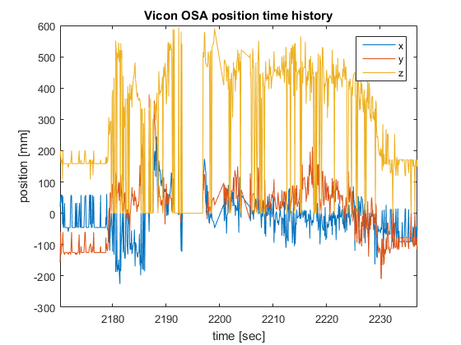
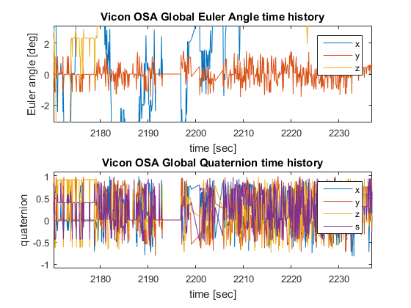
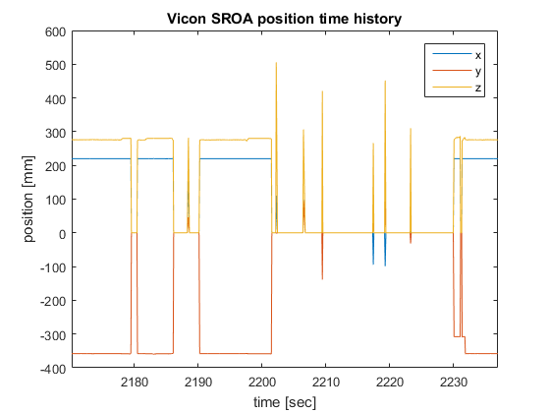
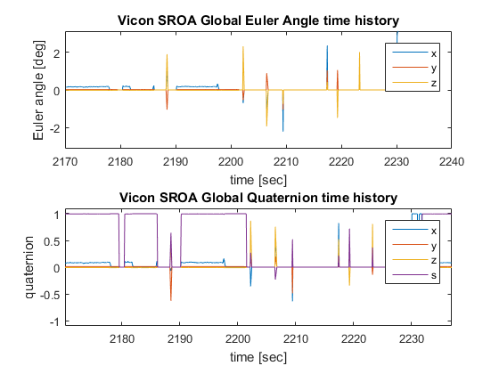
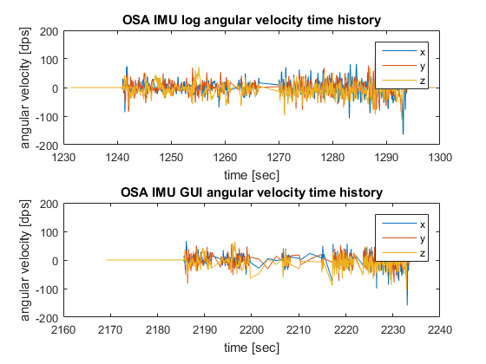
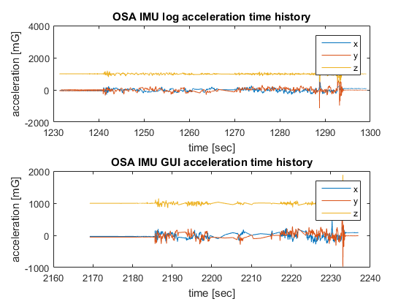
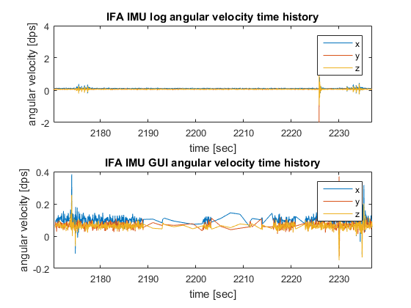
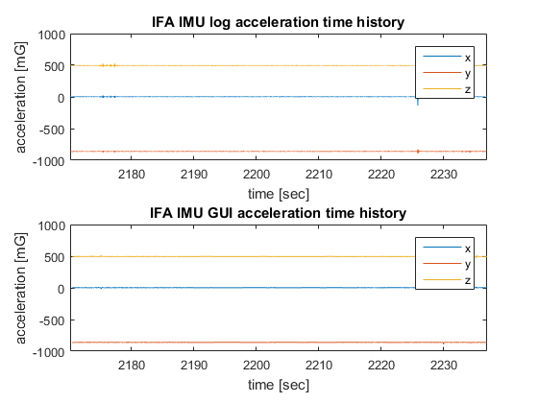
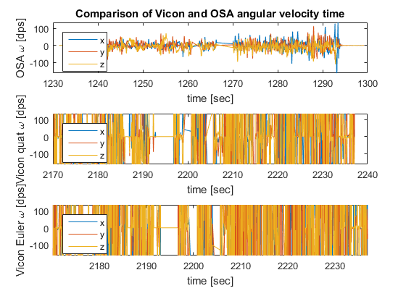
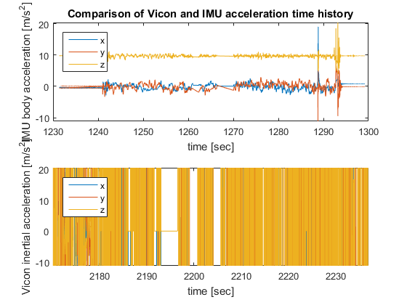
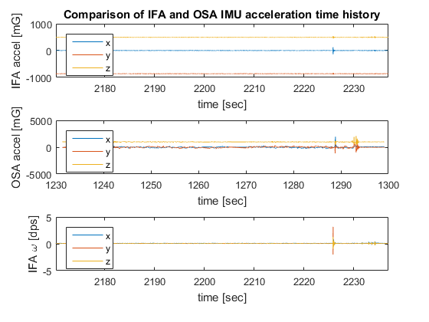
exp =
name: 'SOI_228_1418_1'
type: {'SOI'}
displacement_set: 228
path_angle_set: 1418
start_time: [1x0 char]
run_number: 1
capture_flag: 0
capture_timestamps: ''
contact_flag: 0
contact_timestamps: ''
OSA_bump_flag: 0
OSA_bump_timestamps: ''
frame_bump_flag: 0
frame_bump_timestamps: ''
good_flag: 0
notes: '-'
Vicon_data: [1x1 struct]
OSA_GUI: [1x1 struct]
OSA_data: [1x1 struct]
IFA_GUI: [1x1 struct]
IFA_data: [1x1 struct]
Notes: -
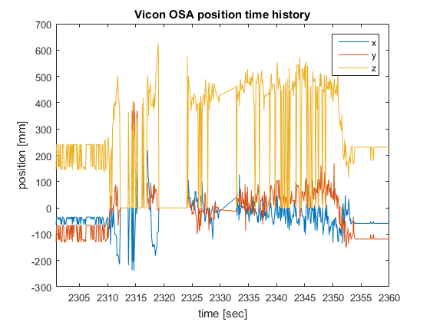
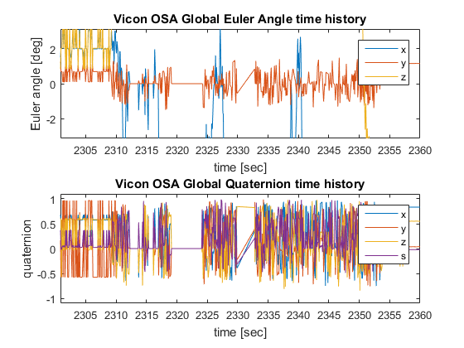
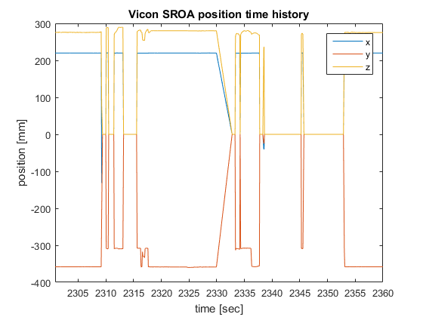
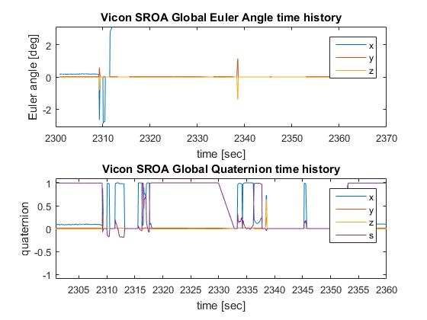
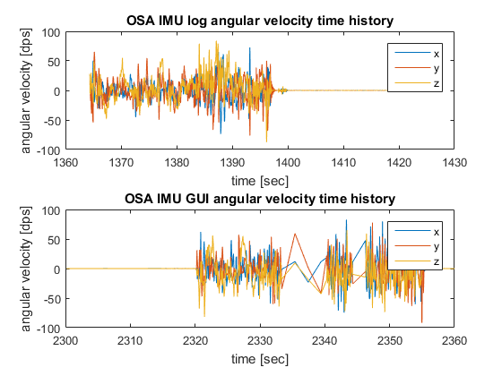
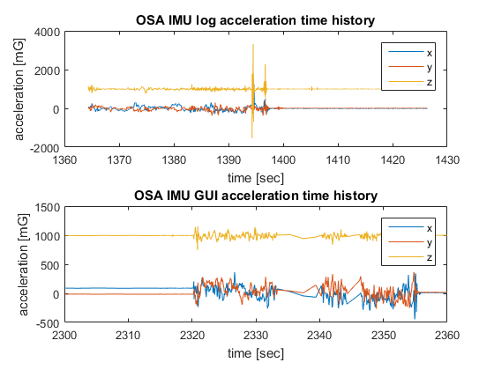
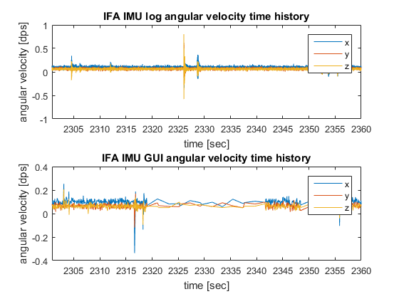
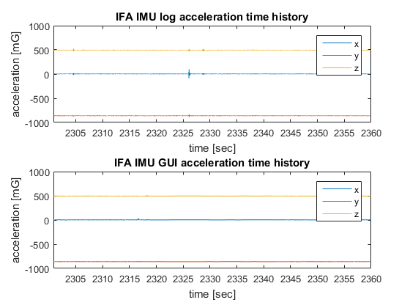
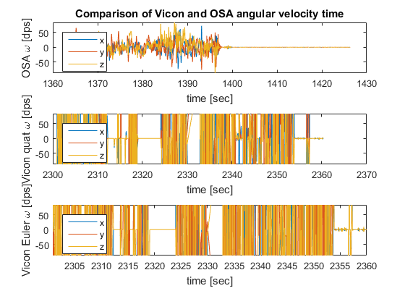
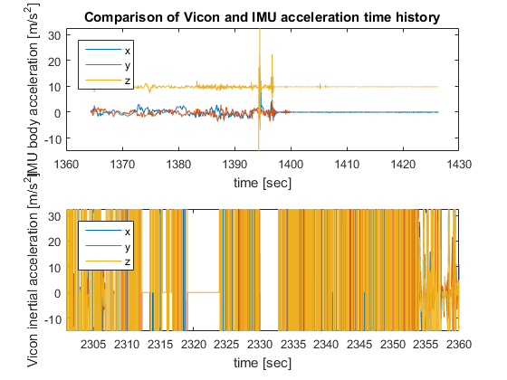
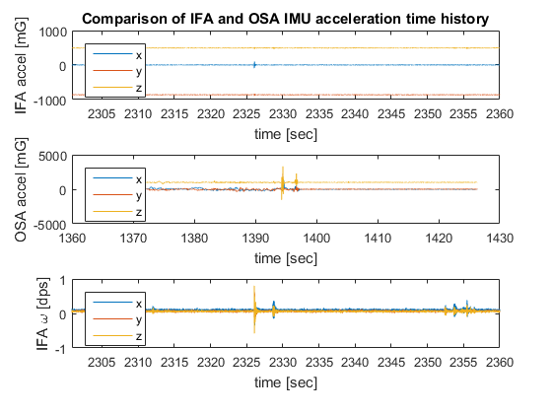
exp =
name: 'SOI_228_1419_1'
type: {'SOI'}
displacement_set: 228
path_angle_set: 1419
start_time: [1x0 char]
run_number: 1
capture_flag: 0
capture_timestamps: ''
contact_flag: 0
contact_timestamps: ''
OSA_bump_flag: 0
OSA_bump_timestamps: ''
frame_bump_flag: 0
frame_bump_timestamps: ''
good_flag: 0
notes: '-'
Vicon_data: [1x1 struct]
OSA_GUI: [1x1 struct]
OSA_data: [1x1 struct]
IFA_GUI: [1x1 struct]
IFA_data: [1x1 struct]
Notes: -
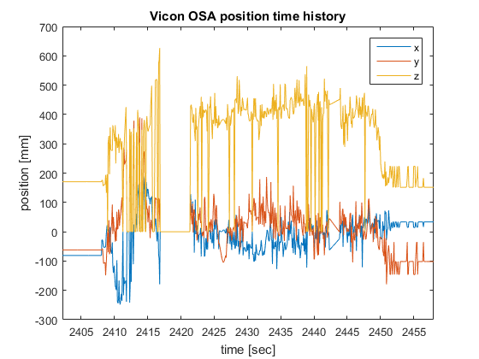
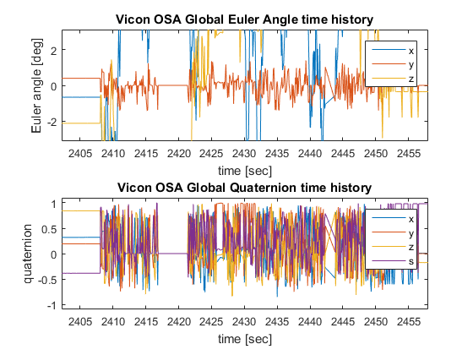
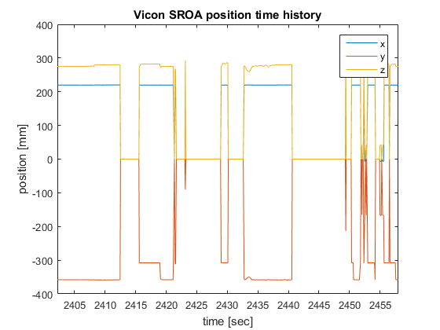
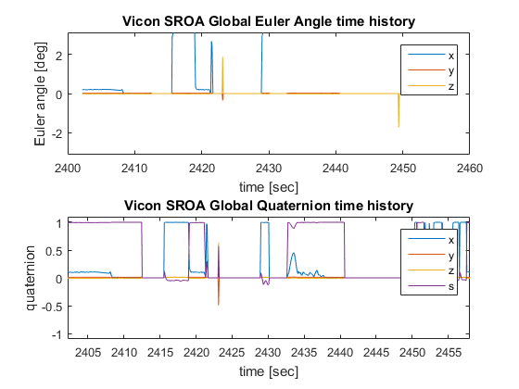
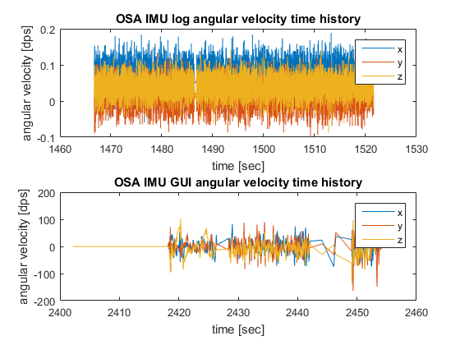
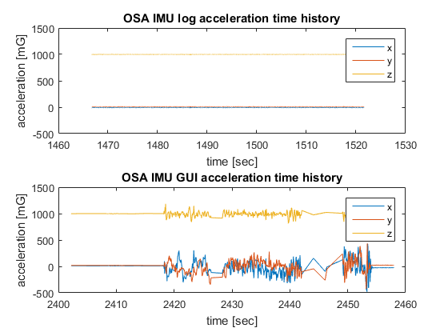
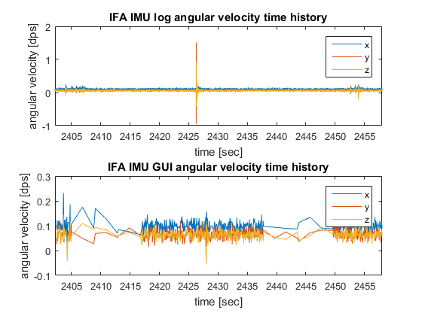
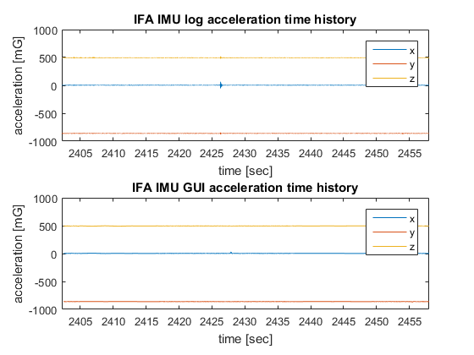
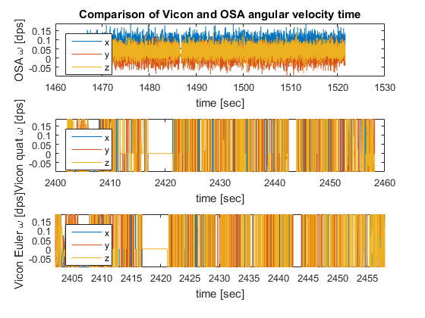
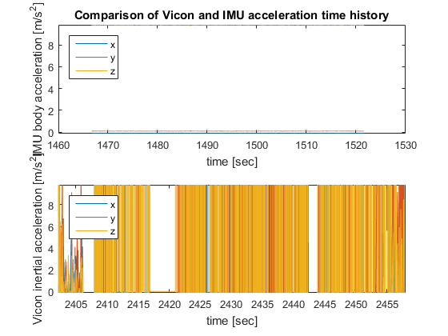
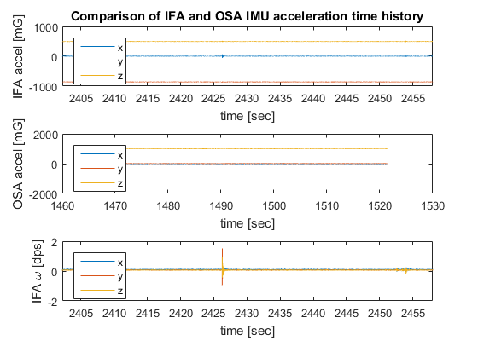
exp =
name: 'SOI_228_1447_1'
type: {'SOI'}
displacement_set: 228
path_angle_set: 1447
start_time: [1x0 char]
run_number: 1
capture_flag: 0
capture_timestamps: ''
contact_flag: 0
contact_timestamps: ''
OSA_bump_flag: 0
OSA_bump_timestamps: ''
frame_bump_flag: 0
frame_bump_timestamps: ''
good_flag: 0
notes: '-'
Vicon_data: [1x1 struct]
OSA_GUI: [1x1 struct]
OSA_data: [1x1 struct]
IFA_GUI: [1x1 struct]
IFA_data: [1x1 struct]
Notes: -
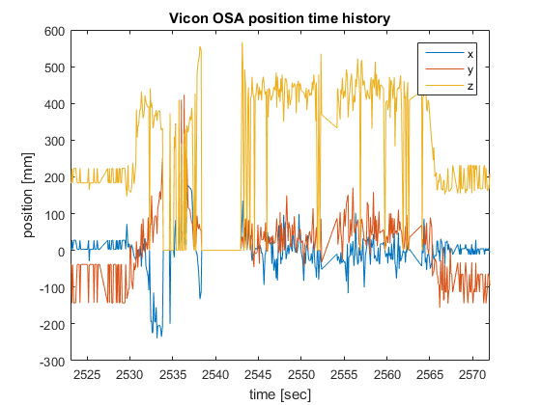
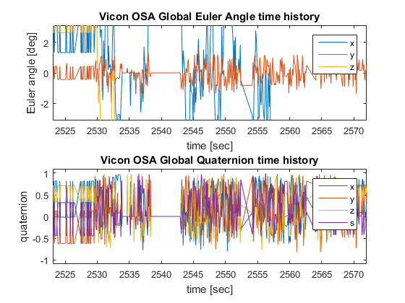
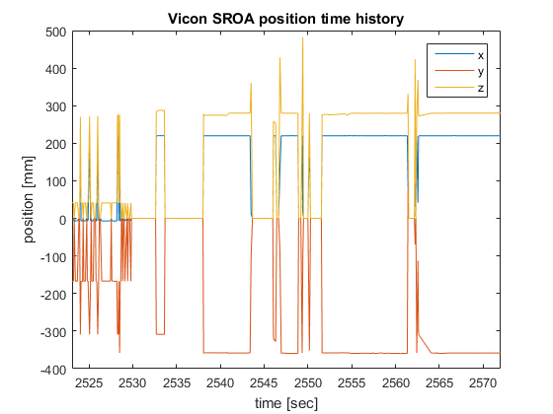
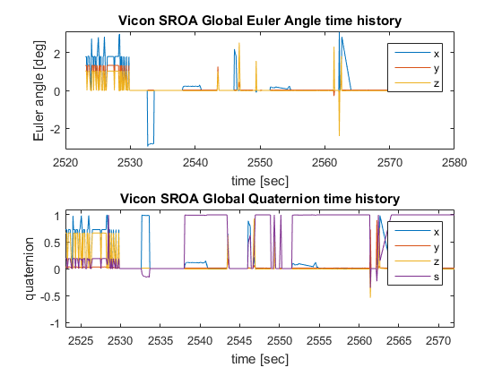
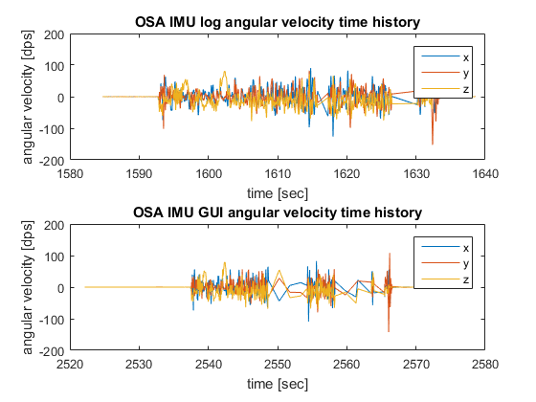
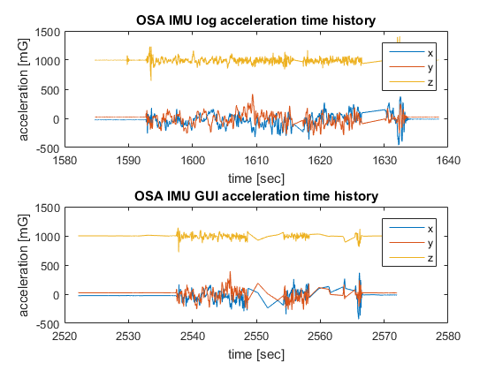
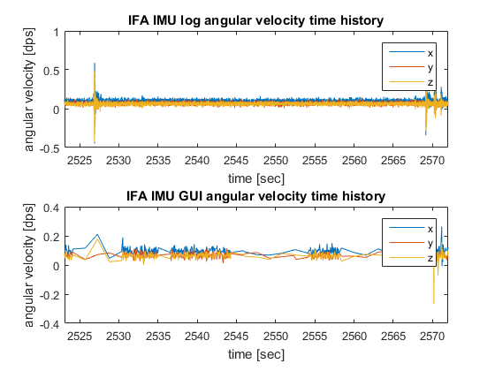
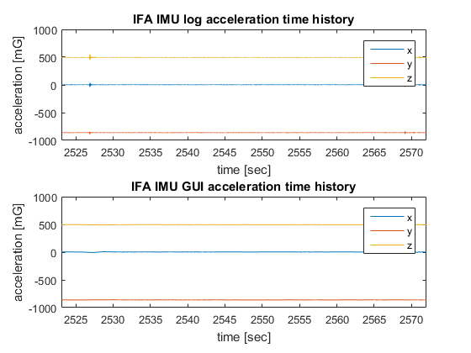
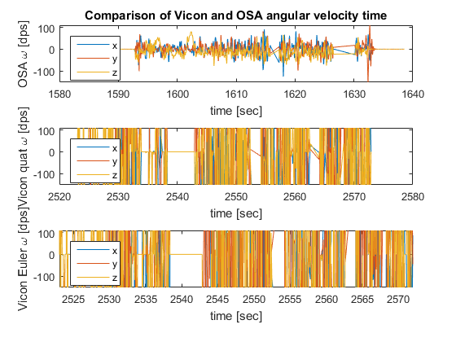
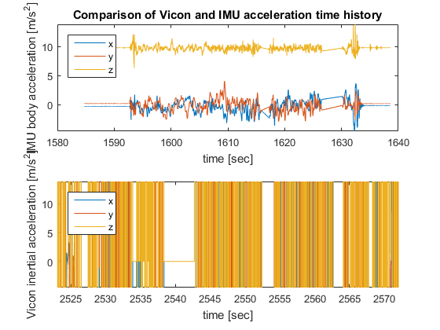
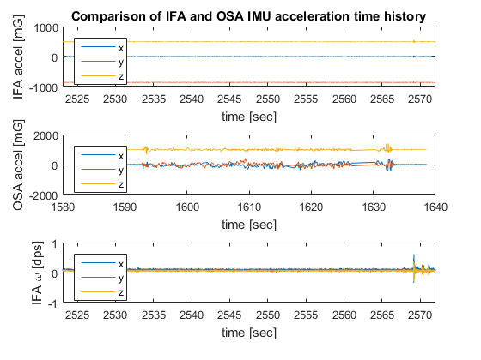
exp =
name: 'SOI_228_1530_1'
type: {'SOI'}
displacement_set: 228
path_angle_set: 1530
start_time: [1x0 char]
run_number: 1
capture_flag: 0
capture_timestamps: ''
contact_flag: 0
contact_timestamps: ''
OSA_bump_flag: 0
OSA_bump_timestamps: ''
frame_bump_flag: 0
frame_bump_timestamps: ''
good_flag: 0
notes: '-'
Vicon_data: [1x1 struct]
OSA_GUI: [1x1 struct]
OSA_data: [1x1 struct]
IFA_GUI: [1x1 struct]
IFA_data: [1x1 struct]
Notes: -
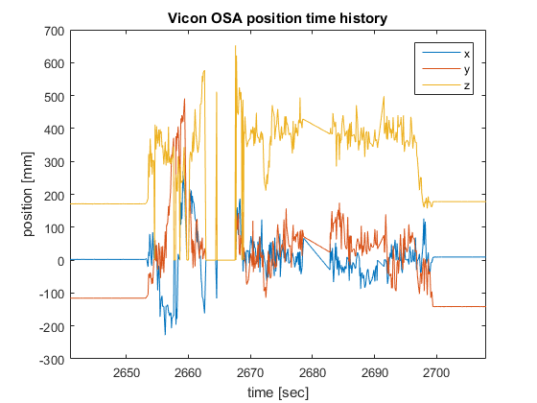
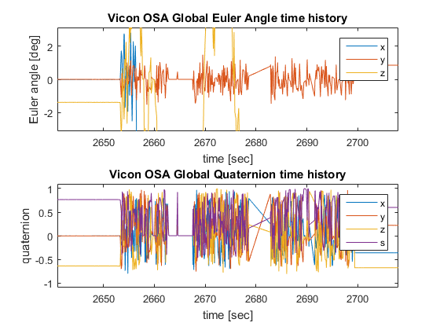
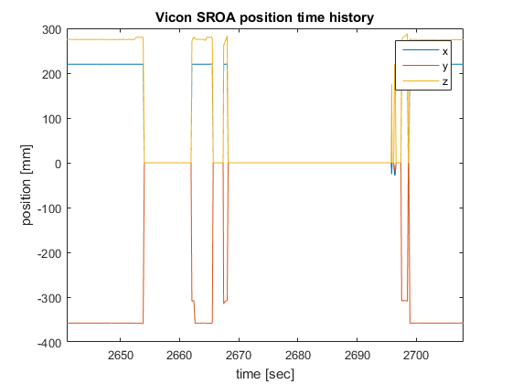
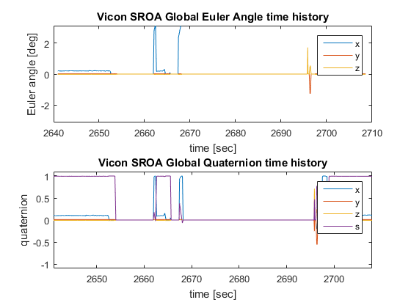
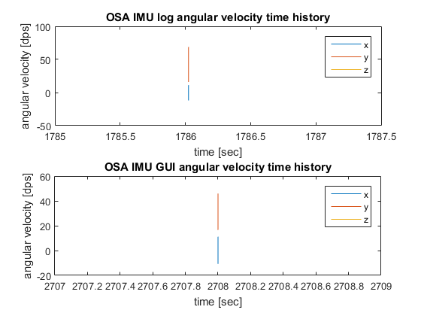
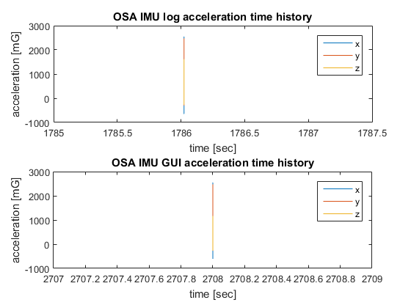
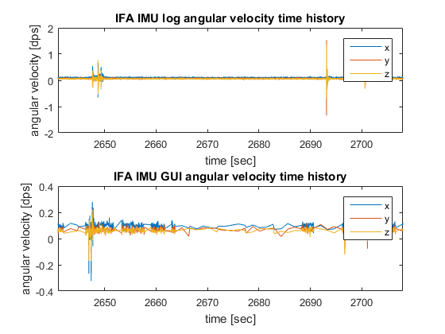
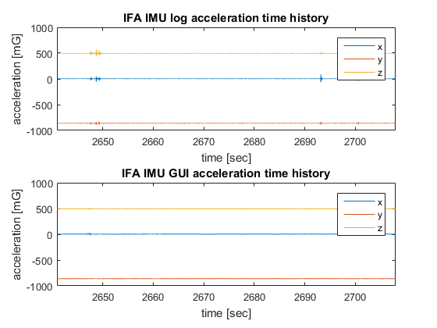
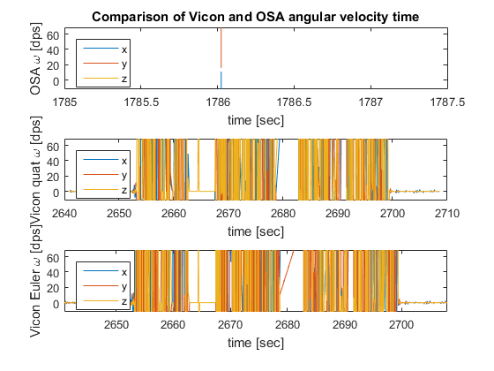
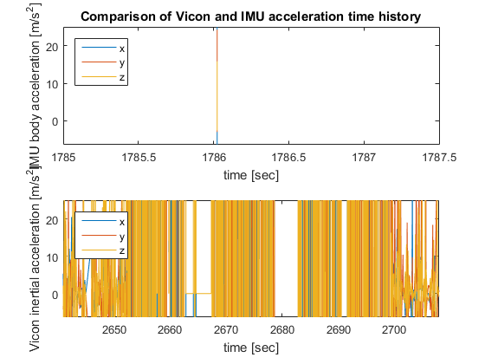
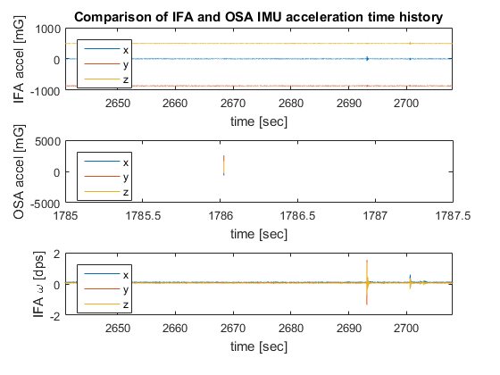
exp =
name: 'SOI_228_1533_1'
type: {'SOI'}
displacement_set: 228
path_angle_set: 1533
start_time: [1x0 char]
run_number: 1
capture_flag: 0
capture_timestamps: ''
contact_flag: 0
contact_timestamps: ''
OSA_bump_flag: 0
OSA_bump_timestamps: ''
frame_bump_flag: 0
frame_bump_timestamps: ''
good_flag: 0
notes: '-'
Vicon_data: [1x1 struct]
OSA_GUI: [1x1 struct]
OSA_data: [1x1 struct]
IFA_GUI: [1x1 struct]
IFA_data: [1x1 struct]
Notes: -
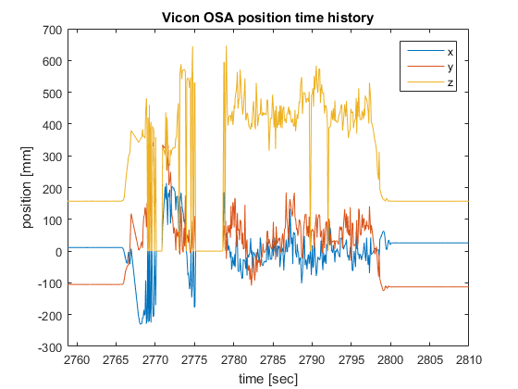
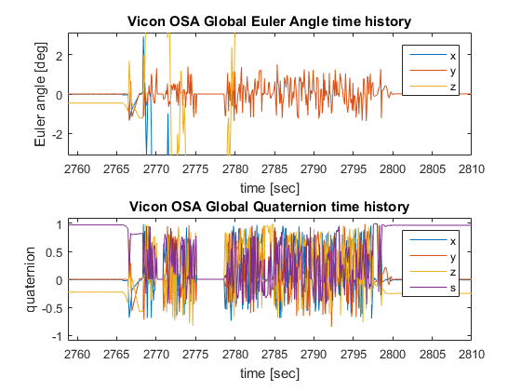
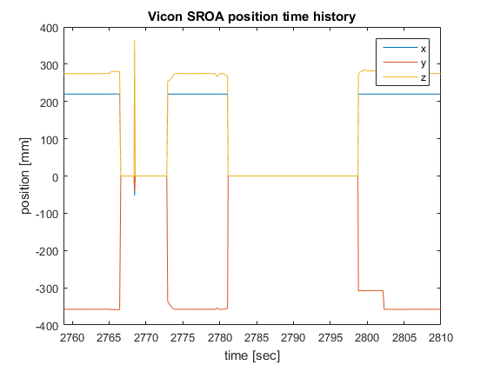
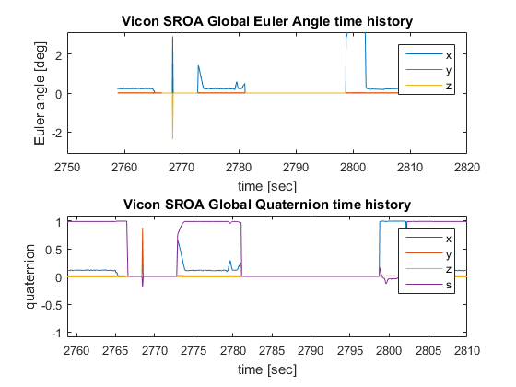
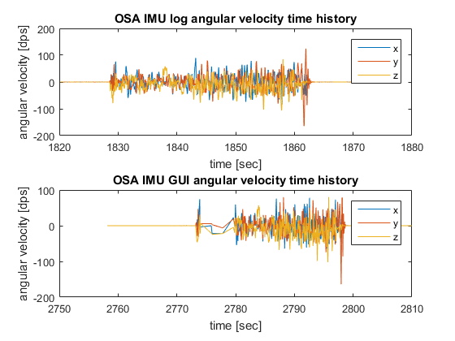
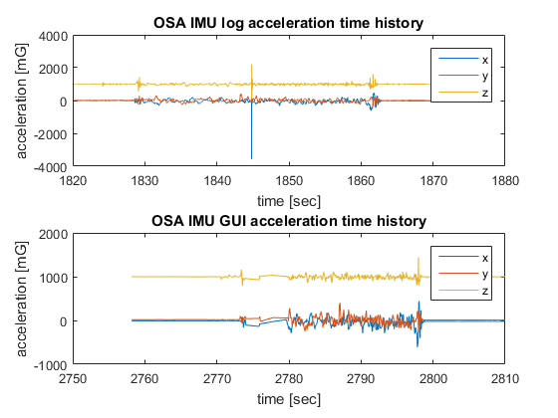
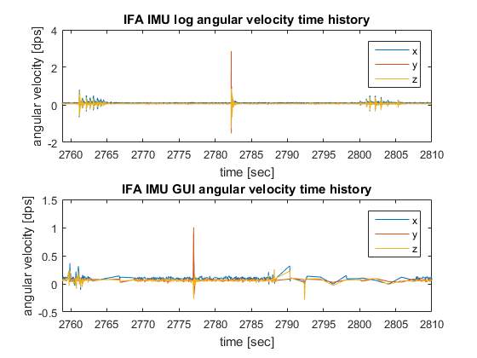
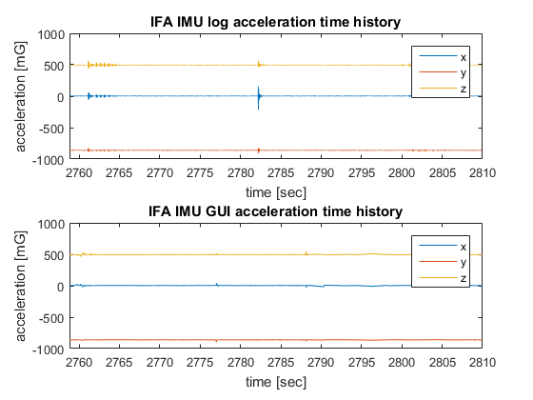
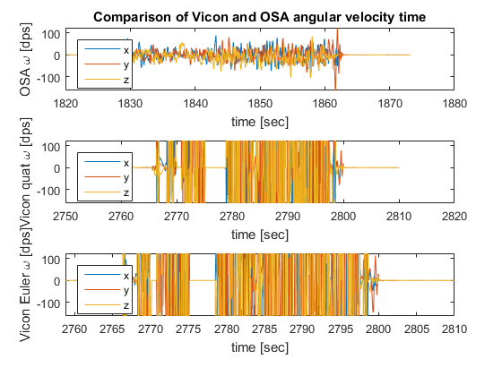
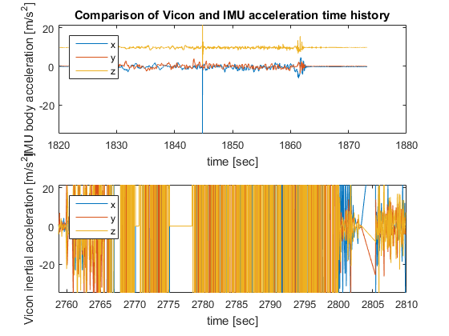
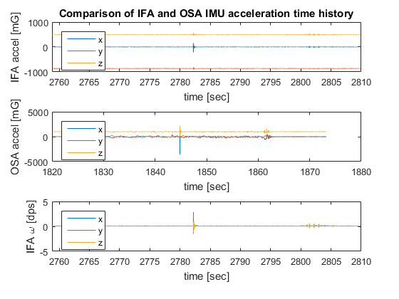
exp =
name: 'SOI_228_1536_1'
type: {'SOI'}
displacement_set: 228
path_angle_set: 1536
start_time: [1x0 char]
run_number: 1
capture_flag: 0
capture_timestamps: ''
contact_flag: 0
contact_timestamps: ''
OSA_bump_flag: 0
OSA_bump_timestamps: ''
frame_bump_flag: 0
frame_bump_timestamps: ''
good_flag: 0
notes: '-'
Vicon_data: [1x1 struct]
OSA_GUI: [1x1 struct]
OSA_data: [1x1 struct]
IFA_GUI: [1x1 struct]
IFA_data: [1x1 struct]
Notes: -
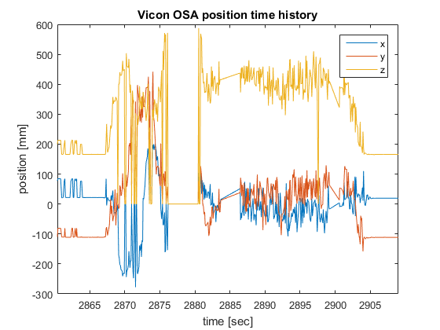
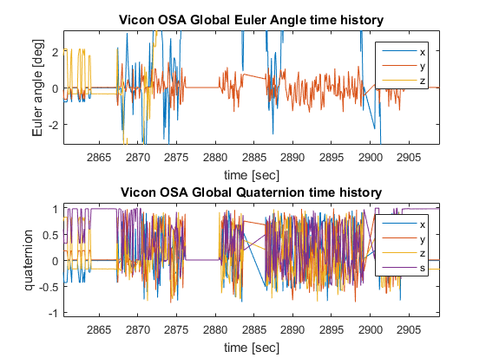
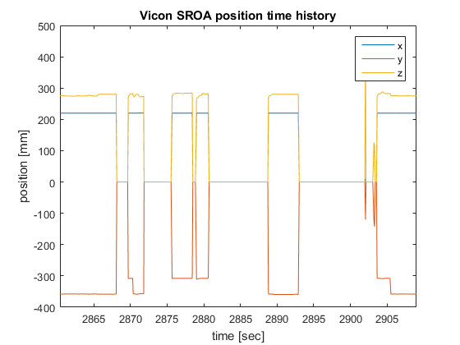
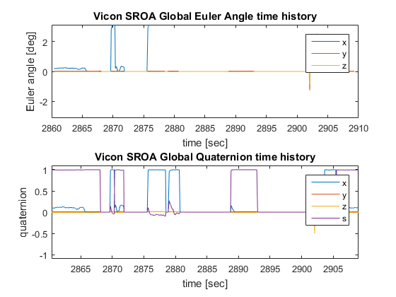
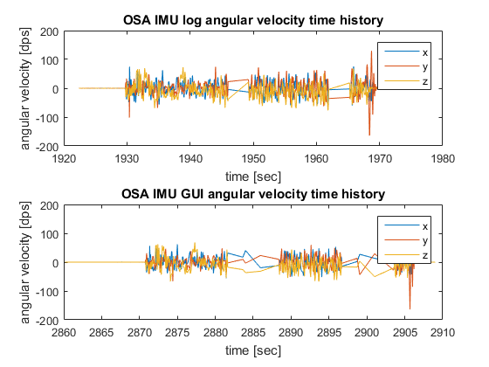
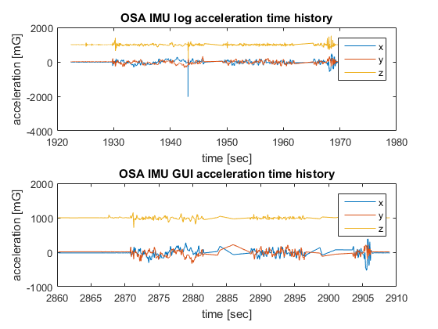
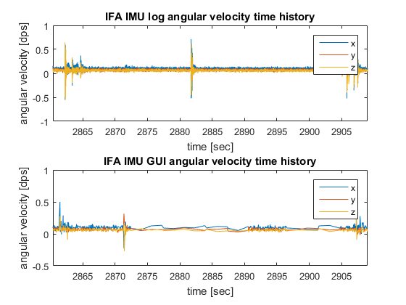
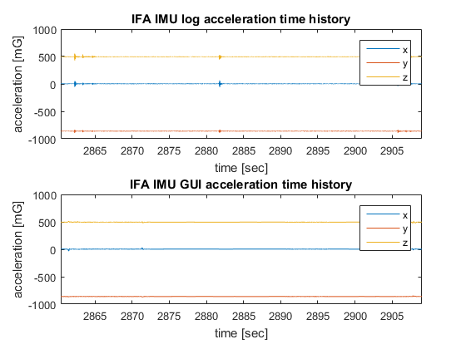
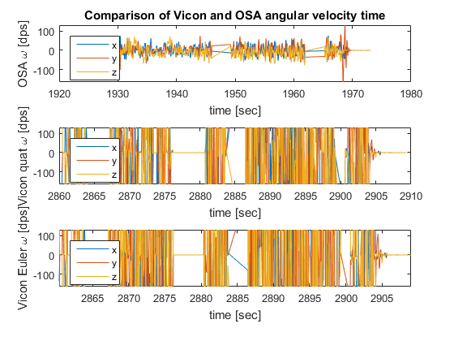
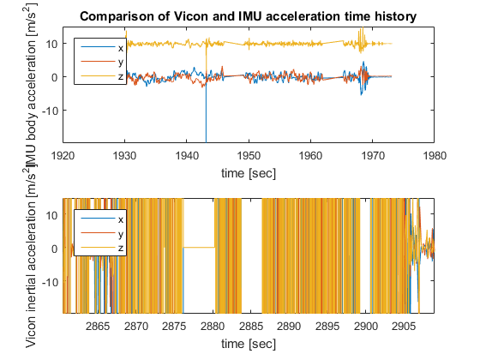
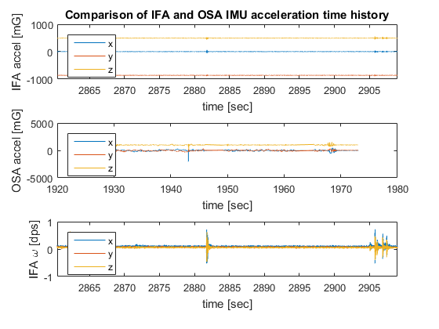
exp =
name: 'SOI_228_1537_1'
type: {'SOI'}
displacement_set: 228
path_angle_set: 1537
start_time: [1x0 char]
run_number: 1
capture_flag: 0
capture_timestamps: ''
contact_flag: 0
contact_timestamps: ''
OSA_bump_flag: 0
OSA_bump_timestamps: ''
frame_bump_flag: 0
frame_bump_timestamps: ''
good_flag: 0
notes: '-'
Vicon_data: [1x1 struct]
OSA_GUI: [1x1 struct]
OSA_data: [1x1 struct]
IFA_GUI: [1x1 struct]
IFA_data: [1x1 struct]
Notes: -
Warning: Plot empty.
Warning: Plot empty.
Warning: Plot empty.
Error using matlab.graphics.axis.Axes/set
While setting the 'YLim' property of 'Axes':
Value must be a 1x2 vector of numeric type in which the second element is larger than the first and may be Inf
Error in ylim (line 43)
set(ax,'ylim',val);
Error in flight_report (line 245)
ylim([min([exp.OSA_data.Gx; exp.OSA_data.Gy; exp.OSA_data.Gz]) ...
end
Published with MATLAB® R2015b

